EXPERIMENT - 1
Set 1: Monthly Sales Data

Dataset: Monthly Sales
Month | Sales (in $)
January | 15000
February | 18000
March | 22000
April | 20000
May | 23000

Question 1
Create a line chart to visualize the monthly sales. Label the axes and title the chart appropriately.

R Code
# Set 1 - Q1: Line chart of monthly sales
months <- c("January","February","March","April","May")
sales <- c(15000,18000,22000,20000,23000)

# Keep month order correct (not alphabetical)
months <- factor(months, levels = months)

plot(months, sales, type = "n",
main = "Monthly Sales Trend",
xlab = "Month", ylab = "Sales (in $)")
lines(1:5, sales, type = "o", col = "blue", lwd = 2, pch = 16)
axis(1, at = 1:5, labels = months)
grid()

Output
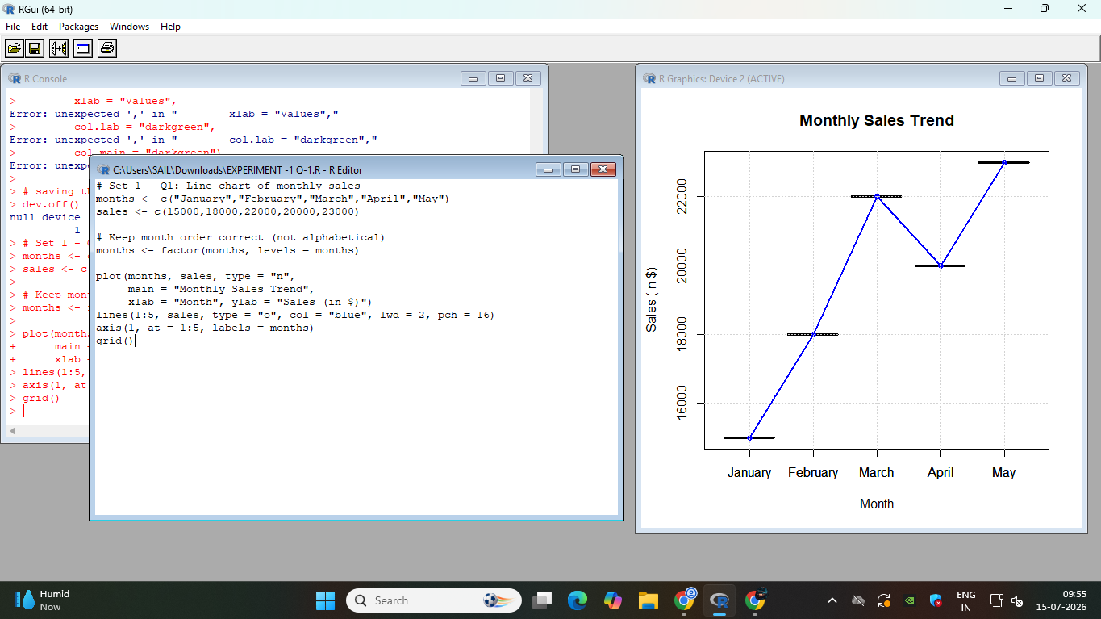

Question 2
Generate a bar chart to display the top-selling products for the year. Label the chart elements.

R Code
# Set 1 - Q2: Bar chart of top-selling products
products <- c("Product A","Product B","Product C","Product D","Product E")
product_sales <- c(45000, 38000, 52000, 30000, 41000)

barplot(product_sales, names.arg = products,
main = "Top-Selling Products of the Year",
xlab = "Product", ylab = "Sales (in $)",
col = "steelblue", ylim = c(0, max(product_sales) + 5000))

Output
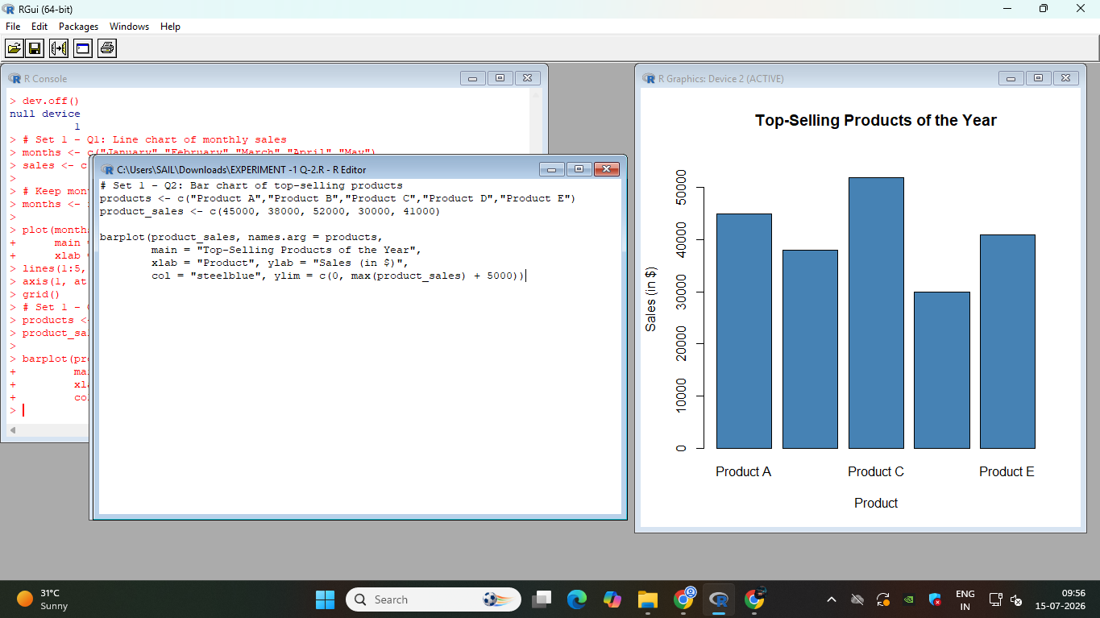

Question 3
Develop a scatter plot to explore the relationship between advertising budget and monthly sales. Explain the insights drawn from the scatter plot.

R Code
# Set 1 - Q3: Scatter plot - Advertising Budget vs Sales
ad_budget <- c(2000, 2500, 3200, 2800, 3500) # sample data ($)
sales <- c(15000, 18000, 22000, 20000, 23000)

plot(ad_budget, sales,
main = "Advertising Budget vs Monthly Sales",
xlab = "Advertising Budget (in $)", ylab = "Sales (in $)",
pch = 19, col = "darkred")
abline(lm(sales ~ ad_budget), col = "blue", lwd = 2)

correlation <- cor(ad_budget, sales)
cat("Correlation between Advertising Budget and Sales:", round(correlation, 3), "\n")

if (correlation < -0.5) {
cat("Finding: There is a strong negative correlation between advertising budget and sales.\n")
cat("This would suggest higher ad spend is associated with lower sales, which is unusual\n")
cat("and may indicate other factors are influencing sales more strongly.\n")
} else if (correlation > 0.5) {
cat("Finding: There is a strong positive correlation between advertising budget and sales.\n")
cat("This suggests that increased advertising spend is associated with higher monthly sales,\n")
cat("indicating advertising is likely an effective driver of revenue.\n")
} else {
cat("Finding: There is a weak or negligible correlation between advertising budget and sales.\n")
cat("This suggests advertising spend alone does not strongly explain changes in sales.\n")
}

Output
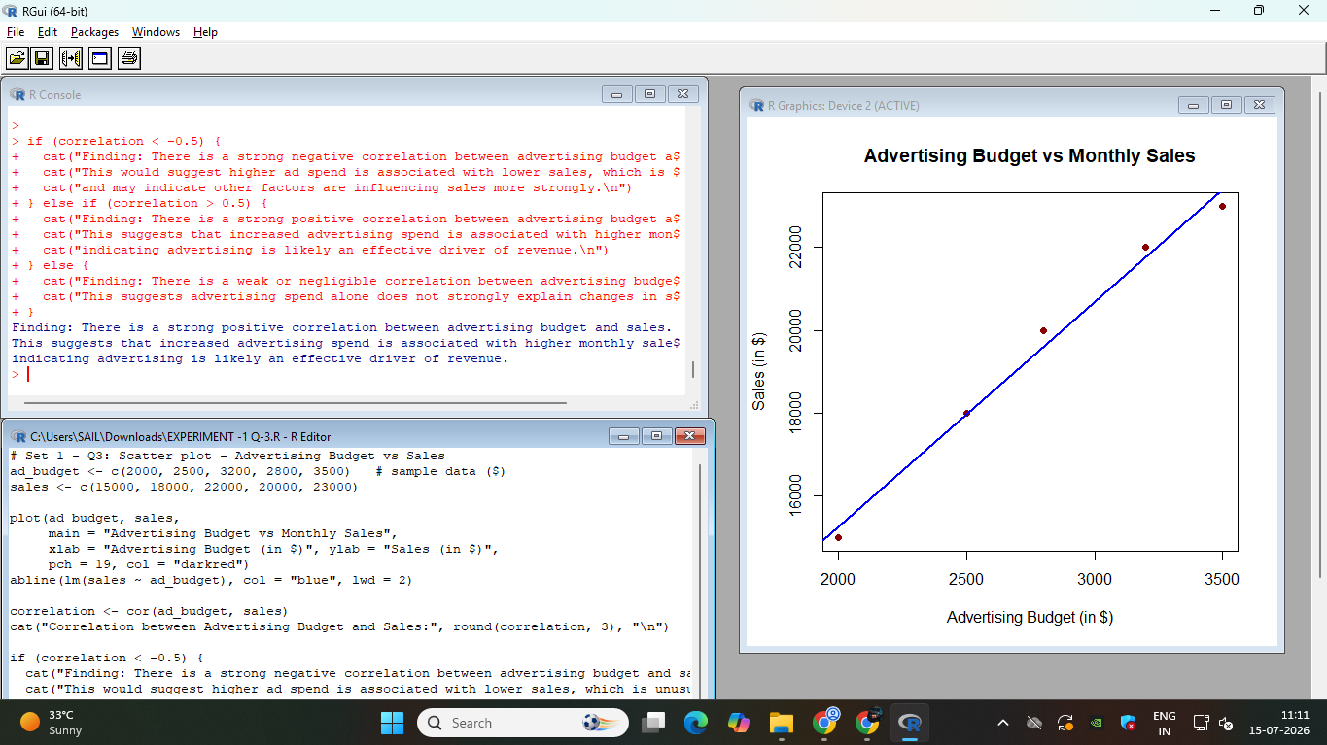

Question 4
Build an interactive dashboard combining the line chart and bar chart to allow users to explore sales data interactively.

R Code
# Set 1 - Q4: Enhanced Interactive Dashboard
library(tcltk)

months <- c("January","February","March","April","May")
sales <- c(15000,18000,22000,20000,23000)
products <- c("Product A","Product B","Product C","Product D","Product E")
product_sales <- c(45000, 38000, 52000, 30000, 41000)

draw_dashboard <- function(n_months, highlight_product) {
par(mfrow = c(1, 2))

# Line chart
plot(1:n_months, sales[1:n_months], type = "o", col = "blue", lwd = 2, pch = 16,
xaxt = "n", main = "Monthly Sales Trend",
xlab = "Month", ylab = "Sales (in $)",
xlim = c(1, 5), ylim = c(0, max(sales) + 2000))
axis(1, at = 1:5, labels = months)

# Bar chart with highlighted product
bar_colors <- rep("steelblue", length(products))
bar_colors[products == highlight_product] <- "darkorange"
barplot(product_sales, names.arg = products,
main = "Top-Selling Products", xlab = "Product", ylab = "Sales (in $)",
col = bar_colors)

par(mfrow = c(1, 1))

# Update total sales label
total <- sum(sales[1:n_months])
tkconfigure(total_label, text = paste("Total Sales (selected months): $", total))
}

# --- Build the Tk window ---
tt <- tktoplevel()
tkwm.title(tt, "Sales Dashboard")

tkgrid(tklabel(tt, text = "Select number of months to display:"))
month_choice <- tclVar("5")
slider <- tkscale(tt, from = 1, to = 5, orient = "horizontal", variable = month_choice,
command = function(...) {
draw_dashboard(as.numeric(tclvalue(month_choice)), tclvalue(product_choice))
})
tkgrid(slider)

tkgrid(tklabel(tt, text = "Highlight a product:"))
product_choice <- tclVar("Product A")
product_menu <- tk2combobox <- ttkcombobox(tt, textvariable = product_choice, values = products, state = "readonly")
tkgrid(product_menu)
tkbind(product_menu, "<<ComboboxSelected>>", function(...) {
draw_dashboard(as.numeric(tclvalue(month_choice)), tclvalue(product_choice))
})

reset_btn <- tkbutton(tt, text = "Reset", command = function() {
tclvalue(month_choice) <- "5"
tclvalue(product_choice) <- "Product A"
draw_dashboard(5, "Product A")
})
tkgrid(reset_btn)

total_label <- tklabel(tt, text = "Total Sales (selected months): $")
tkgrid(total_label)

draw_dashboard(5, "Product A") # initial view

Output
